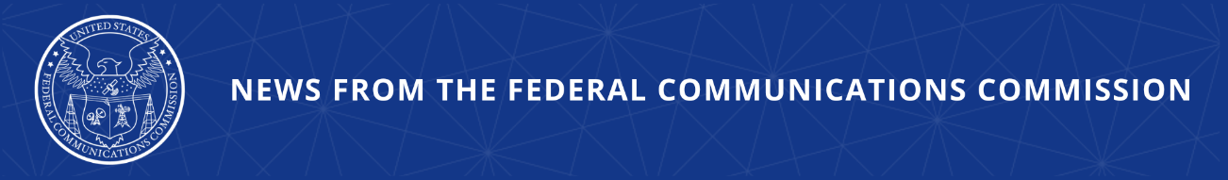

FCC to Review E-Rate Program to Ensure it Fulfills Congress’s Vision for Great Educational Outcomes

WASHINGTON, June 25, 2026—Today, the Federal Communications Commission launched a proceeding that aims to empower parents and better protect children when using networks and services eligible for discounts under the FCC’s E-Rate program, including by limiting screen time. The Notice adopted today seeks to ensure that E-Rate-funded networks and services are being used for educational purposes, while also strengthening E-Rate program integrity and streamlining program administration to support learning opportunities.

Under the FCC’s E-Rate program, eligible schools, libraries, and consortia that include eligible schools and libraries, may apply for discounts on eligible telecommunications, Internet access, and internal connections services.

The Notice seeks comment on actions the Commission could take to ensure that the E-Rate program advances student learning outcomes and better protects the online safety of children when using E-Rate-funded networks and services, particularly given the number of hours per day children of all ages now spend online. Recognizing the increased use of the Internet and connected devices by children, including in educational settings, the Notice seeks comment on ways the Commission can ensure that E-Rate program funds are being spent responsibly and for an educational purpose, as required by law.

In addition, the Commission seeks comment on whether its current interpretation of the Children’s Internet Protection Act (CIPA) is the best reading of that statute and whether existing CIPA requirements sufficiently protect children from inappropriate and harmful content when using school and library computers to access E-Rate-funded networks. Lastly, the Notice seeks comment on potential legal and policy considerations for assessing children’s screen time and protecting children and empowering parents, guardians, and teachers in decision-making involving children’s access to E-Rate-funded networks and services.

The Further Notice of Proposed Rulemaking adopted today proposes further actions to strengthen E-Rate program integrity, including by increasing oversight of consultants, streamlining administrative processes, and eliminating certain rules for the COVID-era Emergency Connectivity Fund program.

Under Chairman Carr, the FCC’s E-Rate program is undergoing a “top-to-bottom” evaluation. During his tenure, Chairman Carr has rolled back unlawful COVID-era expansions of the program, such as funding for off-campus Wi-Fi hotspots and school bus Wi-Fi, as those actions exceeded the FCC’s authority and wasted limited universal service funds. These continuing efforts are part of a larger effort to implement tougher oversight of all USF programs to combat waste, fraud and abuse, and ensure strict program integrity.

Action by the Commission June 25, 2026 by Notice of Proposed Rulemaking (FCC 26-41). Chairman Carr and Commissioner Trusty approving. Commissioner Gomez dissenting in part and approving in part. Chairman Carr, Commissioners Gomez and Trusty issuing separate statements.

WC Docket Nos. 26-133, 13-184, 21-93, No. 21-455

###

Media Contact: MediaRelations@fcc.gov / (202) 418-0500
@FCC / www.fcc.gov

